
11 ATAR Human Biology

A2HBY Task 1:
DNA and Protein
Synthesis Test

Weighting 8.5%

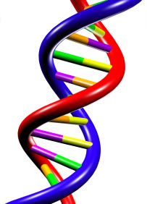

Multiple Choice: 10 marks
Short Answer: 15 marks
Extended Answer: 20 marks
TOTAL 45 MARKS

Section A: Multiple Choice (10 Marks)
Answer all questions by placing and X through the most correct answer on the multiple choice answer sheet.

1. In complementary base pairing in a DNA molecule

(a) cytosine pairs with adenine
(b) guanine pairs with thymine
(c) cytosine pairs with guanine
(d) thymine pairs with adenine

2. A nucleotide consists of each of the following except

(a) nitrogenous bases
(b) sugar
(c) phosphate groups
(d) DNA molecules

3. The following diagram represents a nucleotide with subunits X, Y and Z. X Y Z

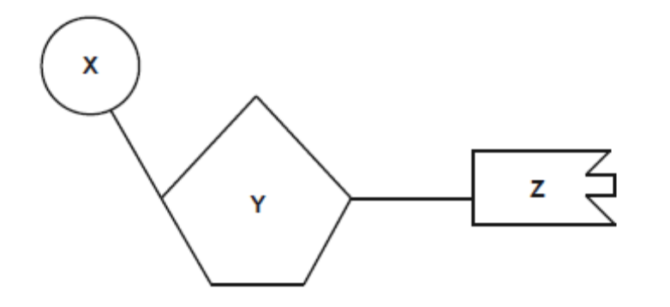

This nucleotide could be identified as a monomer of DNA but not RNA if
- X is ribose.
- Z is thymine.
- Y is phosphate.
- Z is paired with cytosine.

Use the picture below to fill in the missing parts

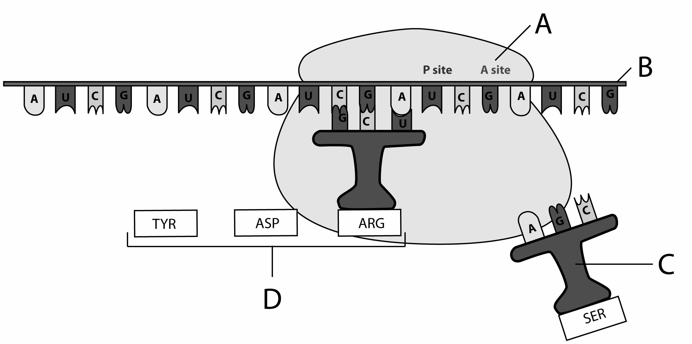

4. A, B C and D respectively are:

- mRNA, tRNA, proteins, ribosome.
- Ribosome, tRNA, mRNA, proteins
- Ribosome, mRNA, tRNA, proteins.
- Ribosome, proteins, mRNA, tRNA

5. Fill in the labels for A and B to show expression of DNA

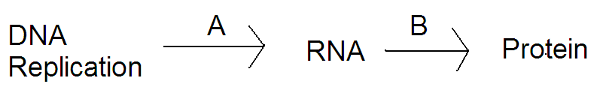

- A= junk DNA, B= amino acid.
- A=DNA, B=translocation.
- A=transcription B=translation.
- A=translation, B=transcription.

In questions 6 and 7 below, a segment of DNA has one strand with the following sequence of bases. A G C G C A T A G C A A

6. The complementary strand of DNA is

a) T C G C C G A T C G T T
b) T C G C G T A T C G T T
c) T C G C A T T A C A U U
d) T C G W R O N G A C U U

7. The mRNA molecule coded for by the original

a) T C G C G T A T C G T T
b) U C G C G U A U C G U U
c) U A C A T T U C A G G G
d) U C G G C A T T U G G C

The next TWO questions refer to the diagrams below that show two parts of a process occurring inside a cell.

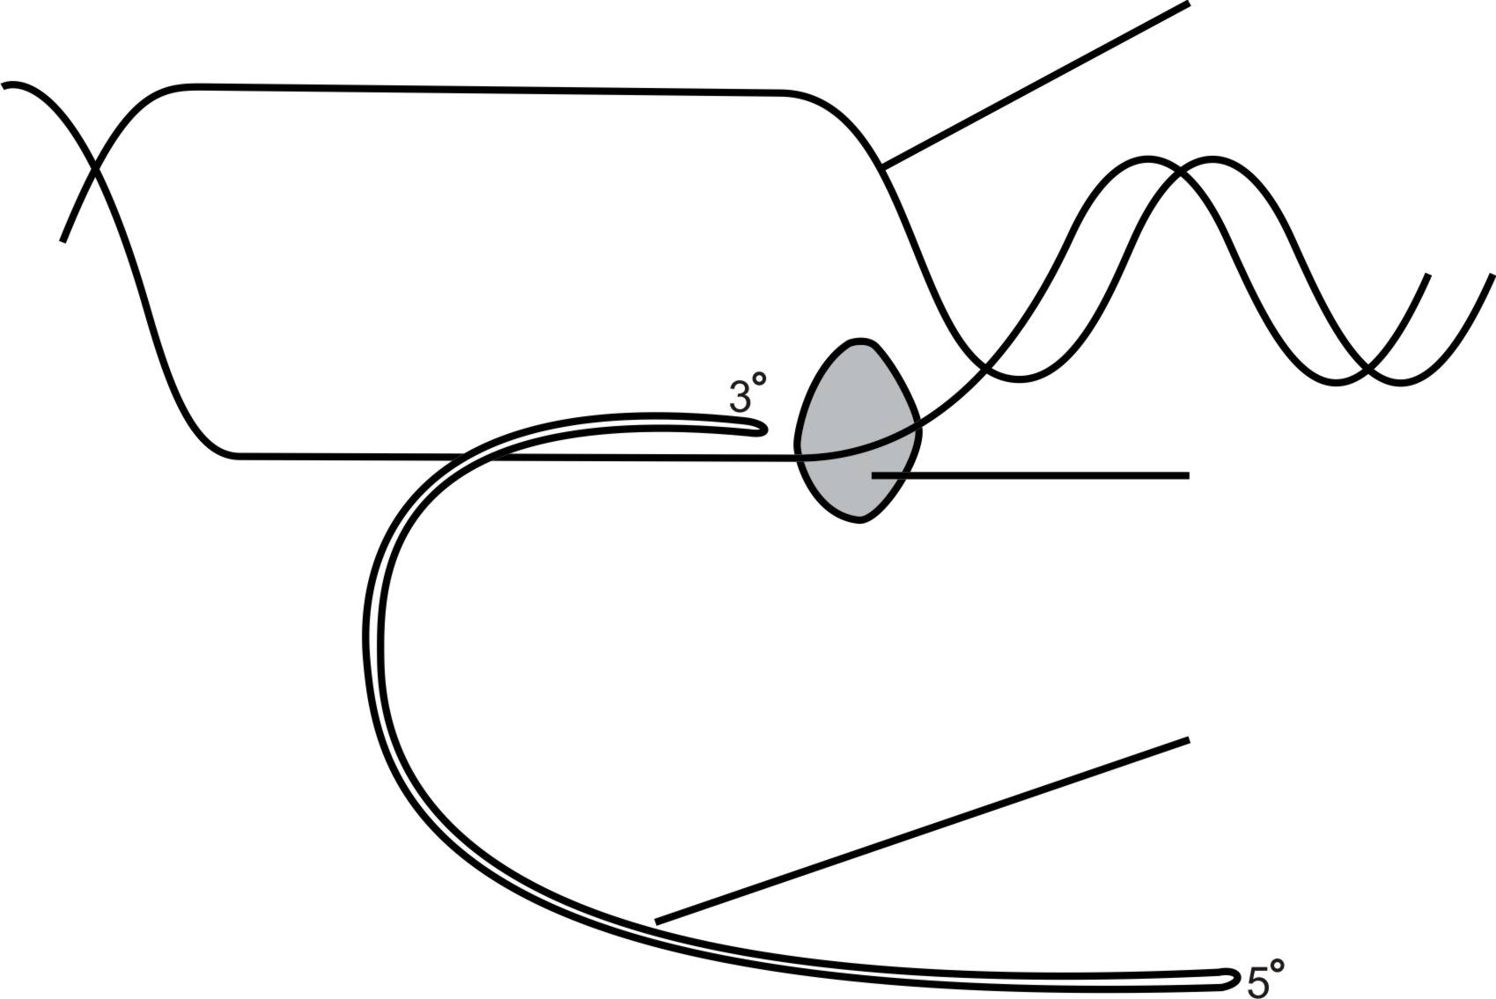
E
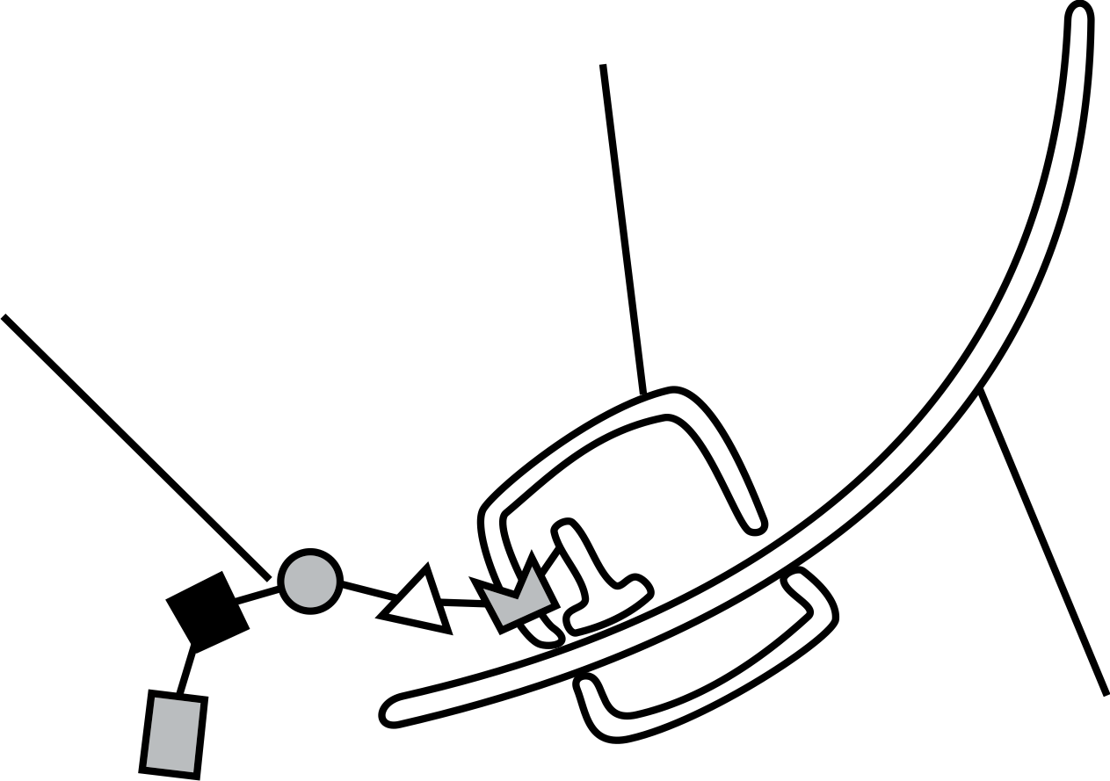
C

D
G

F

F

Stage A Stage B

8. Which of the following statements about the process, indicated in the diagrams above, is correct?

a) Stage A is transcription as the mRNA is being converted to DNA.
b) Stage B is translation and occurs inside the nucleus.
c) Structure C is the ribosome where tRNA is formed.
d) Structure D is the polypeptide chain formed from amino acids.

9. Structure E and structure F are different because structure F

a) contains thymine not uracil.
b) is double stranded not single stranded.
c) is constructed from deoxyribose sugars not ribose sugars.
d) leaves the nucleus, unlike structure E.

The next two questions refer to the following diagram

The diagram below shows a simplified model of a part of a DNA molecule.

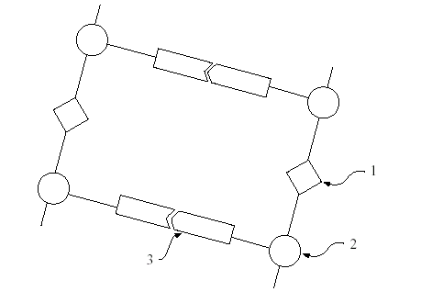
- The parts labelled 1, 2, and 3 are respectively

- nucleotide base, phosphate group, and sugar molecule.
- nucleotide base, sugar molecule, and phosphate group.
- phosphate group, nucleotide base, and sugar molecule.
- phosphate group, sugar molecule, and nucleotide base.

END OF MULTIPLE CHOICE
11 ATAR Human Biology

Test 1:
DNA and Protein Synthesis

NAME:_____________________________

DATE:______________________________

Section A: Multiple choice (10 Marks)
Answer all questions by placing and X through the most correct answer on the multiple choice answer sheet.

1. a b c d
2. a b c d
3. a b c d
4. a b c d
5. a b c d
6. a b c d
7. a b c d
8. a b c d
9. a b c d
10. a b c d
Section B – Short Answer (15 marks)
Answer all questions in the spaces provided.

1.
The table shows that 20% of the bases in a section of double-stranded DNA are adenine (A).
Complete the table below by identifying the other three base types and calculating the percentage of each base type in the section of double-stranded DNA.

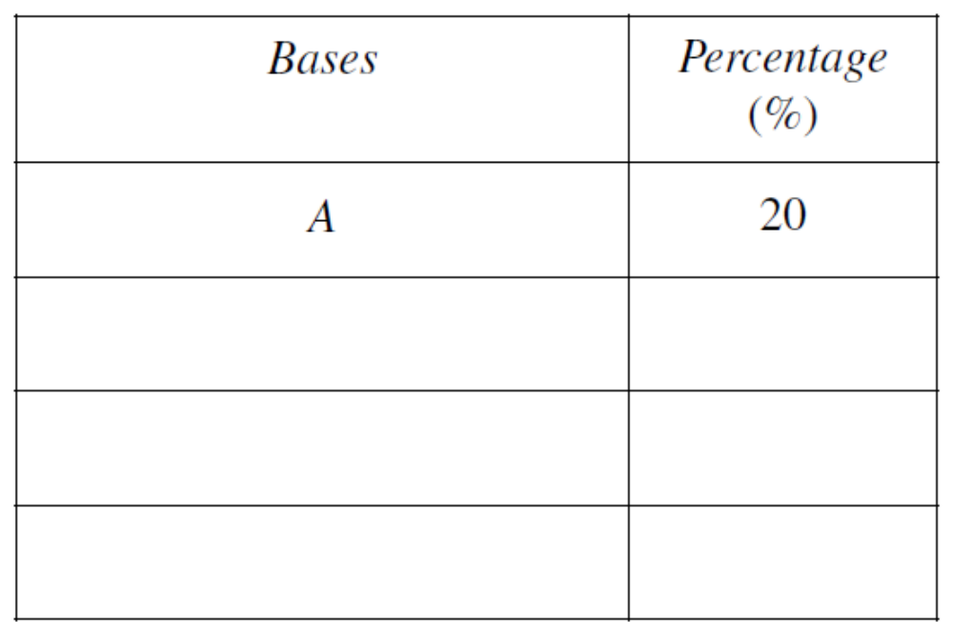
(3 marks)
Construct a simple flowchart to describe the process of DNA replication.

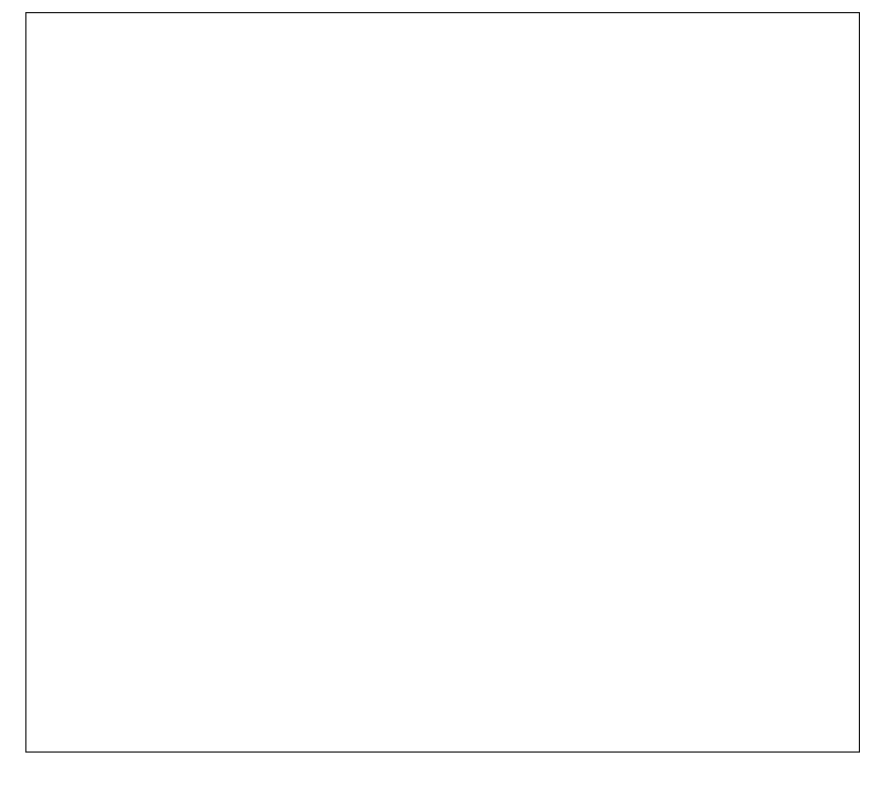 (6 marks)

2. The diagram shows how DNA is used to code for specific amino acids (2 marks)
which join to make a particular protein

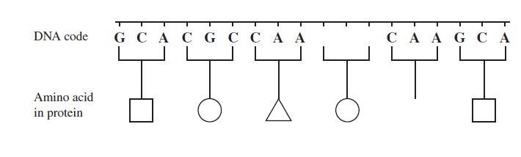
Complete the diagram by
a) adding the missing sequence of bases on the picture provided (1 mark)

b) drawing the symbol for the missing amino acid. (1 mark)

3. Refer to the diagram to answer the following questions. (4 marks)

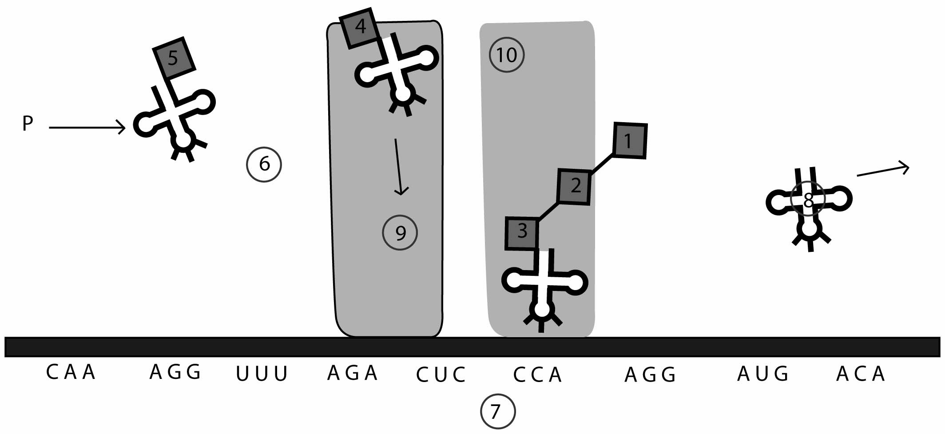
Source picture created by Clinton Ellard

a) Name the following parts:
i. structure 8 ____________________

ii. structure 7 __________________

iii. structure 5 ___________________
(3 marks)

b) What is the codon for amino acid 3 in this chain?

(1 mark)

Section C Extended Answer (20 Marks)
Answer the following question in the space provided.
DO NOT WRITE ANSWERS IN PENCIL. Write your answers on lined pages with each question CLEARLY LABELLED.

Protein synthesis involves two stages, transcription and translation. Describe the main
steps in each of these processes (20 Marks)

